Market concepts analysis
Market research
Marcel W.
Project:
Pokemon card case design
To analyse the different market concepts to identify the state of the market.
[NOT FOR SUBMISSION]
Table of Contents
CHAPTER 1 INTRODUCTION 3
1.1. Structure 3
CHAPTER 2 OVERVIEW 4
CHAPTER 3 CONCEPTS 5
References 6

INTRODUCTION
An effort in analysing the market requires the conceptual understanding of existing products and techniques. A detailed research effort in capturing the information in terms of existing products within the present market will allow a more efficient design effort and reduce wastes.

Structure

OVERVIEW
Chapter which briefly identifies the product within the market in terms of major variations. Such variations may involve different form-factors but essentially are designed to perform the same action.

CONCEPTS
Chapter which focuses on a particular variety, characteristic or method. Only one form-factor may be chosen.

OVERVIEW
The broad overview within the market indicates 4 main categories of variations for the product in question: binder, hardshell, phone case and stand style.
Figure 1: Binder Style
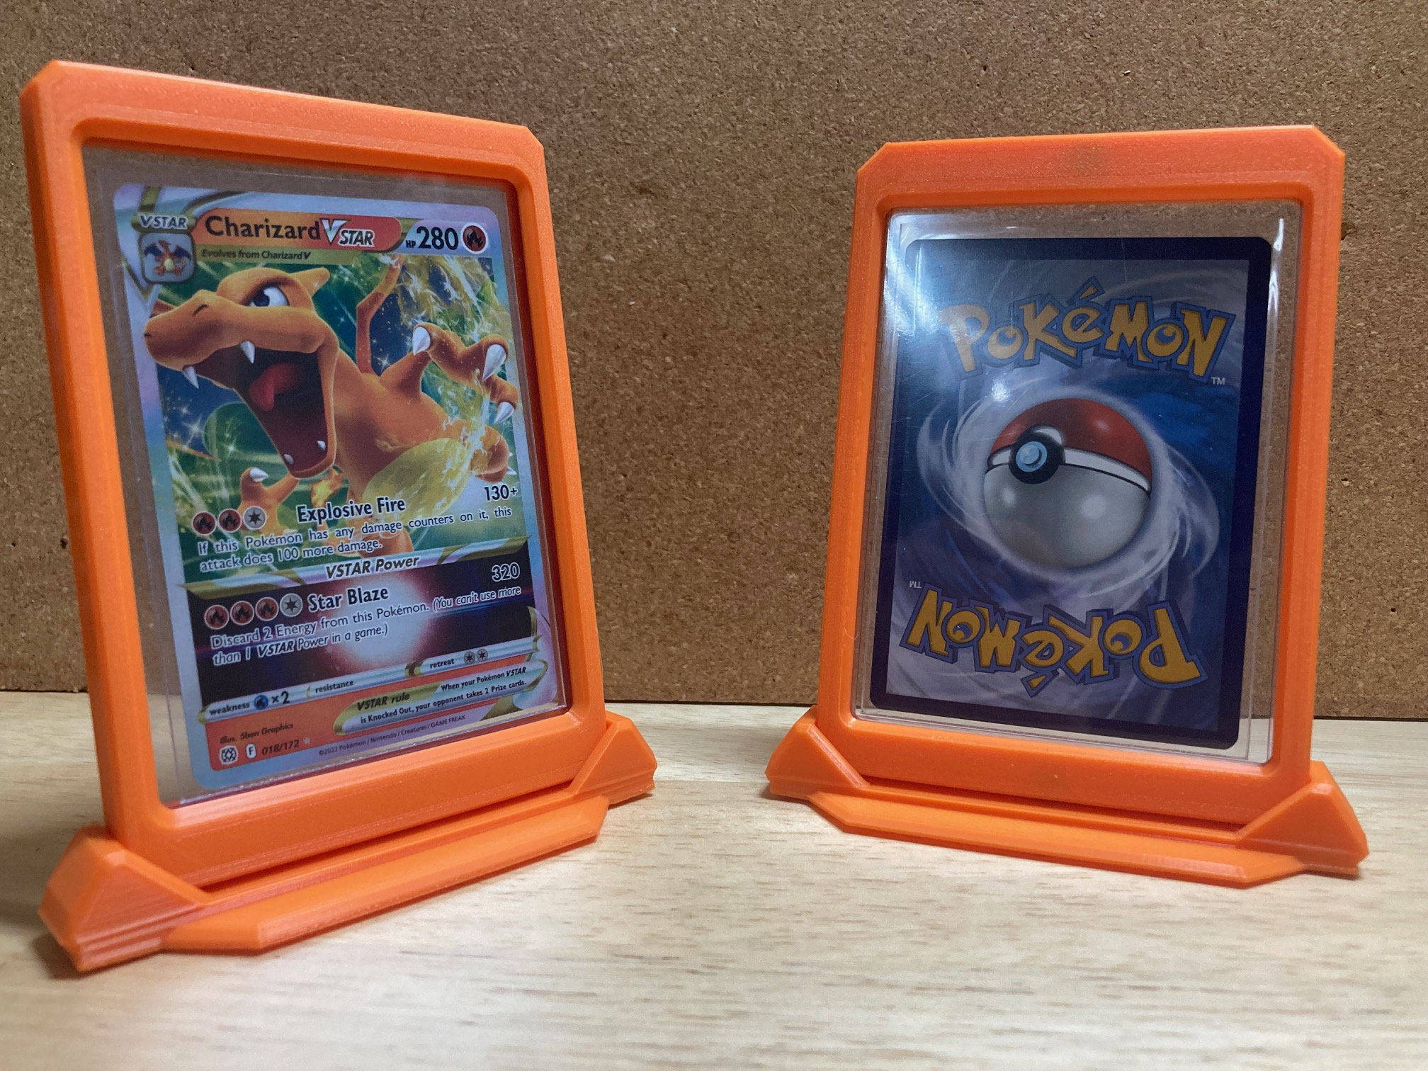Figure 2: Stand Style
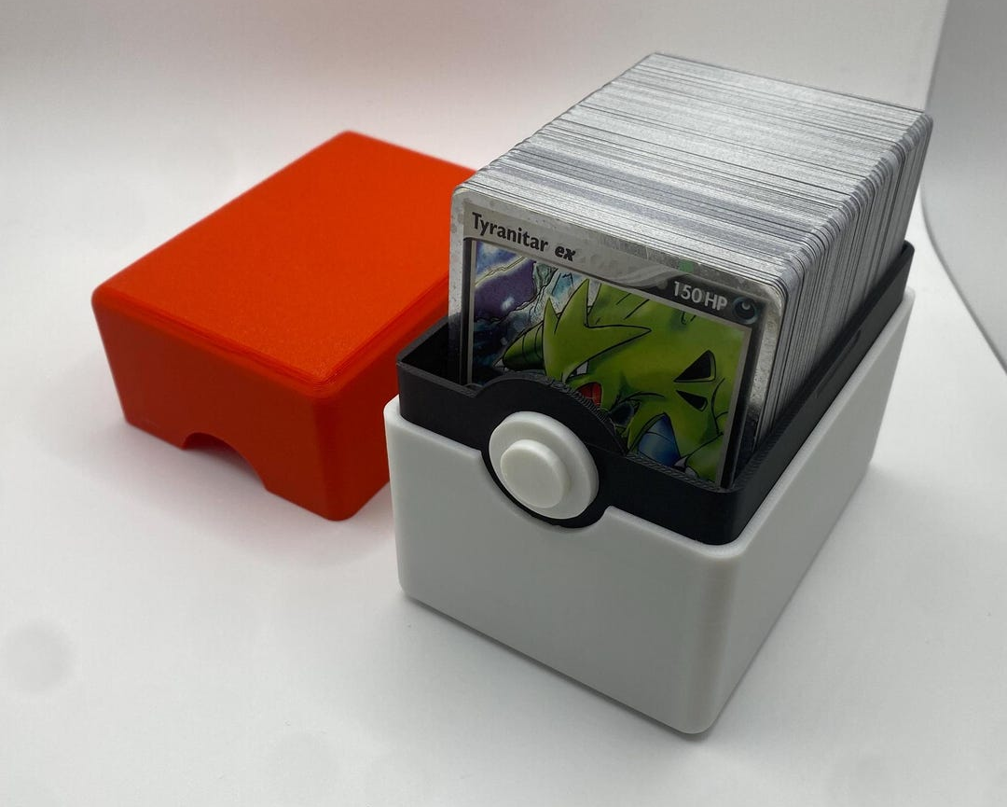Figure 3: Hardshell Style
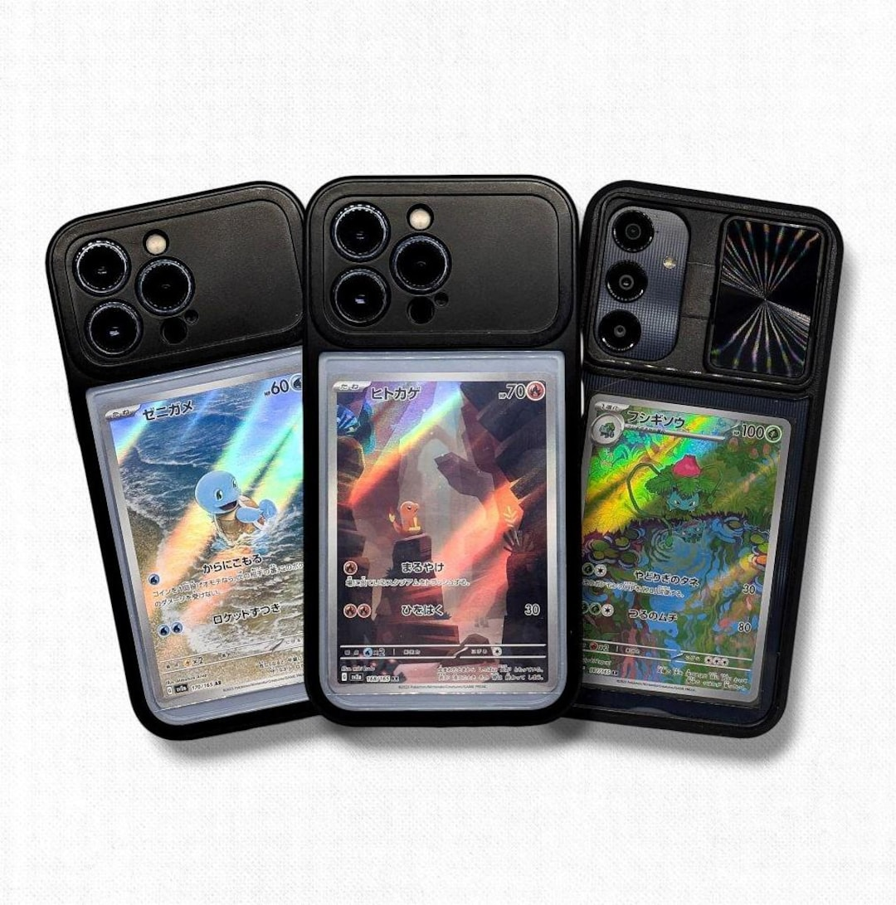Figure 4: Phone Case Style

CONCEPTS
The scope of the project indicates that the end product should be of a hardshell variety. Due to this, the concepts can be filtered to only include hardshell style cases.
Figure 5: Simple hardshell case
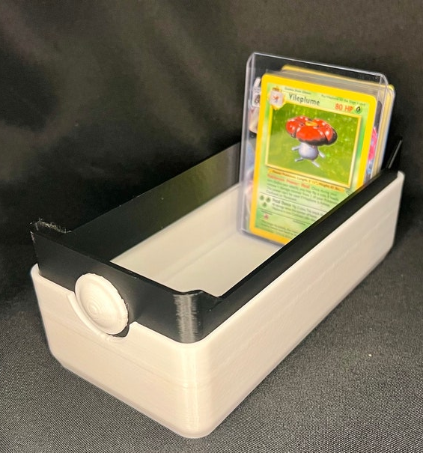Figure 6: Open top stack case

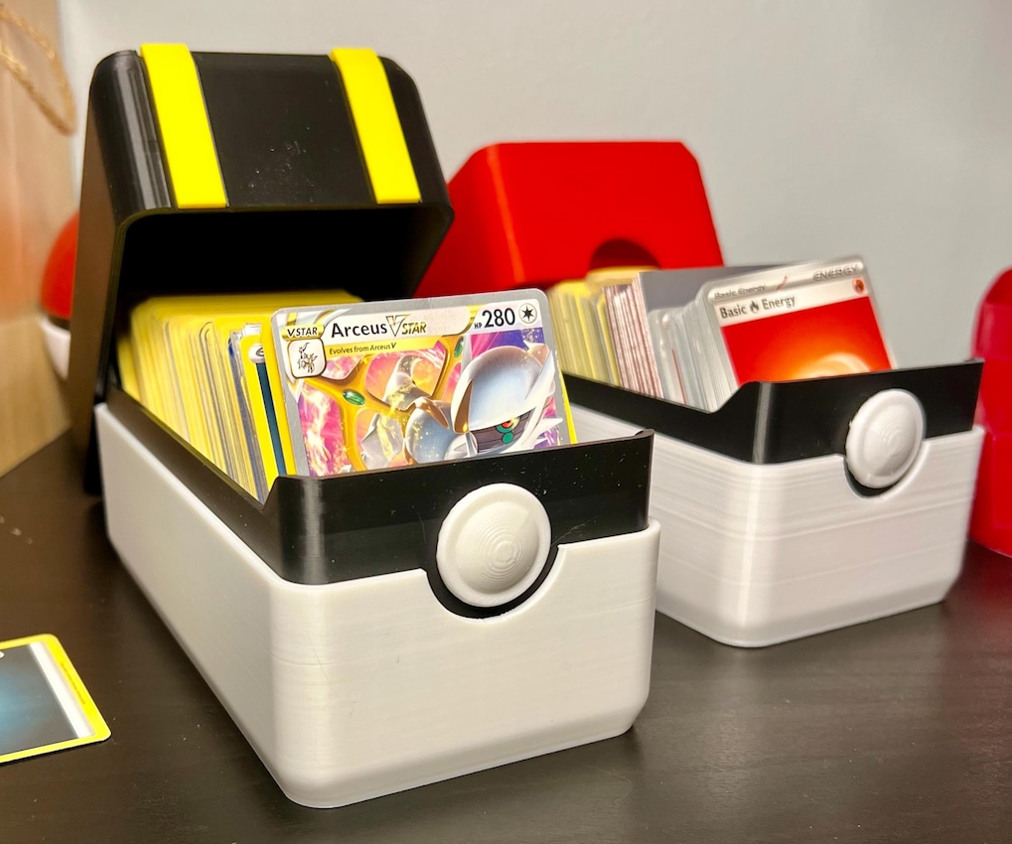Figure 7: Stack case with lid
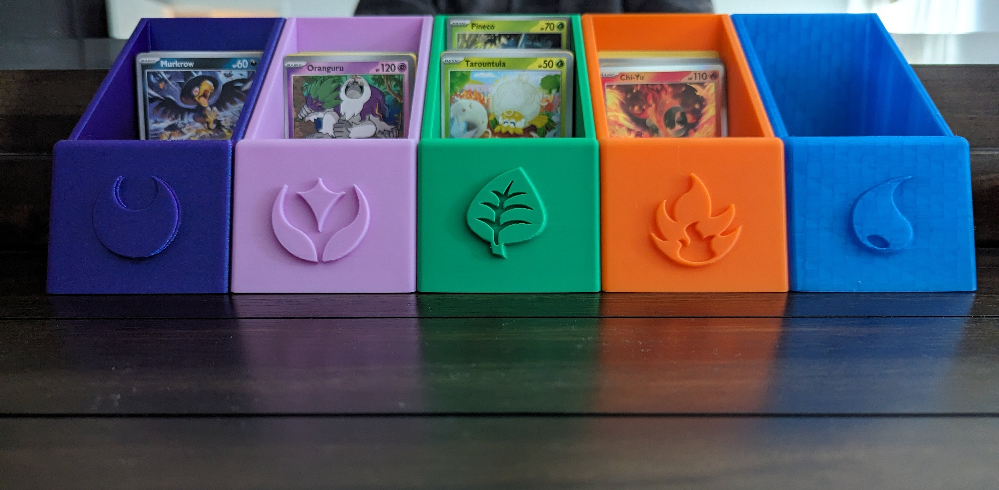Figure 8: Hardshell case arrangement

References

